**1. Introduction**

**Project Introduction**

Today world is full of information and modern technology. Everyone wants to use the technology based on internet, mobile phone for fulfilling their basics need by not wasting their time and rooming here there etc. The project that I proposed is “Online Clothes Shopping” where customers can buy different kinds of clothes of different brands.

**1.1 Justification of project**

**Background of Project**

Online Clothes Shopping is based on web portal. You can buy different products, read reviews, give feedback, use discount offers.

You can review the products, rate, provide feedback at any time anywhere using internet. You just need to register in the website and login to purchase the product. Your product will be delivered on time with adding delivery charge as per the rules and regulation of a company.

Online clothes shopping is very user-friendly where user or customers can easily interact with the system. No need of going to the different shops and try different clothes which will waste your valuable time. You can track your product, check delivery time. I have used PHP for programming and MySQL to manage database of clothes shopping.

**1.2 Problem Statement**

There are many problems related to shopping as you cannot get all the products that you want at a same place, price of the product varies with place to place, need to bargain a lot to get the product at suitable price.

**1.3 Description of project**

**1.3.1 Feature of system**

Some of the features of proposed system are:

**Users can login and register to the website.**

User can register to system from registration form and login through login from which check valid username and password in database.

**User can purchase clothes from home.**

User can purchase the clothes on online and also track their order.

**User can rate the product.**

User can rate movies after watching in theaters.

**User can provide feedback, read reviews.**

User can provide feedback and also provide reviews to the product.

**Admin can add clothes.**

Admin can add products and make changes to the system.

**User can see the offers and discount of products.**

User can see the upcoming offers and discounts products.

**2. Project scope**

**2.1 Scope and limitation**

**Scope**

Online clothes shopping is for shops which helps to store database with information about clothes, price, upcoming offers, rating and reviews of clothes and retrieve by user easily.

**Limitation**

**Some of the limitation are as follows:**

**2.2 Aims and objective**

The main aim of this project is to purchase clothes from online directly from the shop by browsing website from anywhere anytime. Other this project is to reduce numbers of staffs in shop and promote different kinds of clothes on the internet. To maintain custom satisfaction and to promote clothes over internet. System will provide complete detail information of clothes to the customers.

The main objectives of online clothes shopping are to manage all the clothes, customer, price, delivery within a certain times. Its main objective of building this application is to reduce manual work and customer can easily purchase clothes from their home. This will also help to increase the profit of an organization. Other objective of system is to obtain statics information from clothes shopping. To provide anytime anywhere services to the customers.

**3. Development Methodology**

**3.1 Methodology used**

Here for this project I have choose waterfall method. This model is sequential model where the one step must have finished then only another step should begin. In that model all the steps are divided. There are six steps they are Requirement analysis, Design, Implementation, testing, Deployment and Maintenance.

The Waterfall model is the earliest SDLC approach that was used for software development. It is very simple to understand and use. In a waterfall model, each phase must be completed before the next phase can begin and there is no overlapping in the phases.

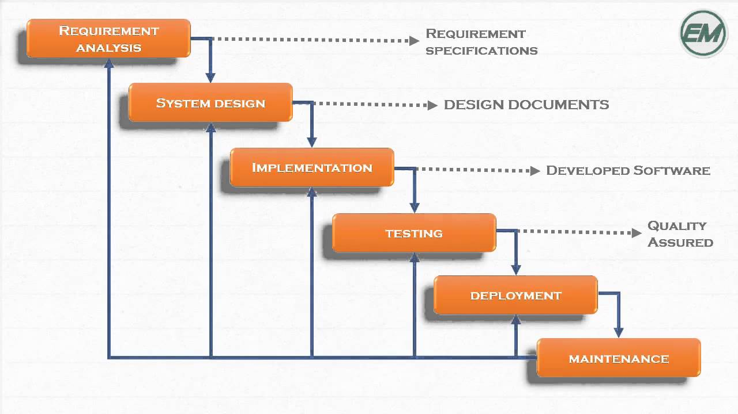

**3.2 Design pattern**

I am using MVC (Model View Controller) design pattern in this project. MVC is Model View Controller which is most used framework in software development in today’s markets. It used on both desktop and web-based application.

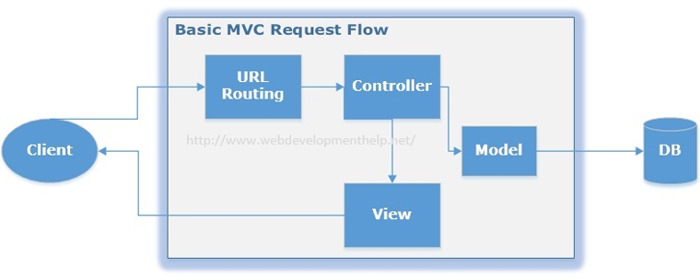

**Model**

Model handles all the data related logic that user work with. It represent data that is transfer between view and controller.

**View**

View handles all UI logic of application.

**Controller**

Controller acts as intermediary between model and view to process incoming requests and logic.

**3.3 System Architecture**

A system architecture is the conceptual model that defines the structure, behavior, and more views of a system. It consist of system components and the sub-systems developed, that will work together to implement the overall system.

**4. Work breakdown structure (WBS) / scheduling**

A work-breakdown structure (WBS)[2] in project management and systems engineering, is a deliverable-oriented breakdown of a project into smaller components. A work breakdown structure is a key project deliverable that organizes the team's work into manageable sections.

**4.1 Work breakdown structure**

|  |  |  |
| --- | --- | --- |
| WBS | Task Name | Number of days |
| 0 | Project Name | 110 |
| 1.  1.1  1.2  1.3  1.4 | **Project Management**  Risk Management  WBS  Configuration Management  Proposal Submission | 16  3  4  4  5 |
| 2.  2.1  2.2  2.3  2.4  2.5 | **Analysis**  Requirement analysis  NLA  Use Case  Architecture (Initial Class Diagram)  Analysis Specification | 27  6  3  5  6  7 |
| 3.  3.1  3.2  3.3  3.4 | **Design**  Structural Diagram  Behavioral Diagram  UI Design  Database Design (ER , Data Dictionary) | 27  7  3  8  9 |
| 4.  4.1  4.2 | **Implementation**  Building Database  Coding | 20  4  16 |
| 5.  5.1  5.2  5.3  5.4 | **Testing**  Unit Testing  Integration Testing  Blackbox Testing  Whitebox Testing | 8  2  2  2  2 |
| 6.  6.1  6.2 | **Deployment**  User Training  Final Report | 13  8  5 |

s

**4.2 Milestone**

|  |  |  |  |
| --- | --- | --- | --- |
| **Milestone** | **Start** | **Deadline** | **No. of days** |
| **Project Management**  Risk Management  WBS  Configuration Management  Proposal Submission | 25th March  28th March  1th April  5th April | 27thMarch  31thmarch  4th April  9th April | 3  4  4  5 |
| **Total days** | 25th March | 9th April | 16 |
| **Analysis**  Requirement analysis  NLA  Use Case  Architecture (Initial Class Diagram)  Analysis Specification | 10th April  16th April  19th April  24th April  30th April | 15th April  18th April  23rd April  29th April  6th May | 6  3  5  6  7 |
| **Total days** | 10th April | 6th May | 27 days |
| **Design**  Structural Diagram  Behavioral Diagram  UI Design  Database Design (ER , Data Dictionary) | 7th May  14th May  17th May  25th May | 13th May  16th May  24th May  3rd June | 7  3  8  9 |
| **Total days** | 7th May | 3rd June | 27 |
| **Implementation**  Building Database  Coding | 4th June  8th June | 7th June  23rd June | 4  16 |
| **Total days** | 4th June | 23rd June | 20 |
| **Testing**  Unit Testing  Integration Testing  Blackbox Testing  Whitebox Testing | 24th June  26th June  28th June  30th June | 25th June  27th June  29th June  31st June | 2  2  2  2 |
| **Total days** | 24th June | 31st June | 8 |
| **Deployment**  User Training  Final Report | 1st July  8th July | 7th July  12th July | 8  5 |
| **Total days** | 1st July | 12th July | 13 |

**Description of milestone**

**Project management**

Idivided 16 days for the project. 3 days for risk management, 4 days for WBS, 4days forConfiguration Management and 5 days for Proposal Submission.

**Analysis**

I have decided 27 days for analysis. In analysis many things to do that’s why need more than other task. 6 days for Requirement analysis, 3 days for NLA, 5 days for use case diagram, 6 days for architecture (Initial Class Diagram) and 7 days for analysis specification.

**Design**

Many designs to do so I allocate 27 days for designing. 7 days for structural design, 3 days for behavior design, 8 days for UI design, 9 days for database design**.**

**Implementation**

For database 4 days and coding for 16 days.

**Testing**

Estimated the days, 2 days for unit testing, 2 day for integration testing, 2 days for black box testing and 2 day white box testing.

**Deployment**

13 days for the final documentation. 8 days for user training and 5 days for Final report

**4.3 Scheduling / Gantt chart**

**5. Risk management**

Risk management is the identification, evaluation, and prioritization of risk followed by coordinated and economical application of resources to minimize, monitor, and control the probability or impact of unfortunate events or to maximize the realization of opportunities.

Some of the possible risks that may arise are:

• Managing the products

• Wrong delivery

• Time consuming

• Server failure

• Due to lack of training

Impact = Likelihood * Consequence

Risk Likelihood values are shown as follows

|  |  |
| --- | --- |
| Likelihood | Value |
| Low | 1 |
| Medium | 2 |
| High | 3 |

Risk Consequence values are shown below

|  |  |
| --- | --- |
| Consequence | Value |
| Very low | 1 |
| Low | 2 |
| Medium | 3 |
| High | 4 |
| Very High | 5 |

Risk Consequence values are shown below

|  |  |  |  |  |  |
| --- | --- | --- | --- | --- | --- |
| **S.N** | **Risks** | **Likelihood** | **Consequence** | **Impact** | **Actions** |
| **1** | Managing the products | 2 | 4 | 8 | Provide proper information about products |
| **2** | Wrong delivery | 2 | 4 | 8 | User must provide proper information |
| **3** | Time consuming | 2 | 4 | 8 | Divide the time for different staffs |
| **4** | Server failure | 1 | 4 | 4 | Backup should be done |
| **5** | Lack of training | 1 | 3 | 3 | provide the training for staffs |

**6. Configuration management**

The term refers to the system which track hardware, software and related information of the system. Configuration management is involving practices of processing system changes systematically with updating system while maintain the system integrity. To achieve of goal of the system, configuration management should be implemented with details policies, procedures to manage to version. Version controls are the category of software tools that helps to manage source code for the software team.

**7. Conclusion of the project**

Online Clothes Shopping is a customized and user friendly a web application where you can buy a different designable clothes from anywhere anytime. It has facilities of buying clothes, read reviews of clothes of different brand, provide feedback, see lists of upcoming product by subscribing. Admin can add different clothes. Suitable breakdown and scheduling are done properly. Design pattern MVC and waterfall methodology is used for the project.

**References**